**Digital Marketing Assignment -2**

|  |  |
| --- | --- |
| Student Name | Ramkumar A |
| Student Register Number | 953720106024 |
| College Name | AAA College of Engineering and Technology |
| Naan Mudhalvan ID | 3E6B37E1784D368932A45B438FA0D9C7 |

**Assignment:**

Create Facebook Business page and post one social media poster

**Solution:**

FACEBOOK PAGE

Link: [https://www.facebook.com/profile.php?id=61550223766231&mibextid=ZbWKwL](https://www.facebook.com/profile.php?id=61550223766231&mibextid=ZbWKwL%20%20%20%20%20%20%20%20%20%20%20%20)

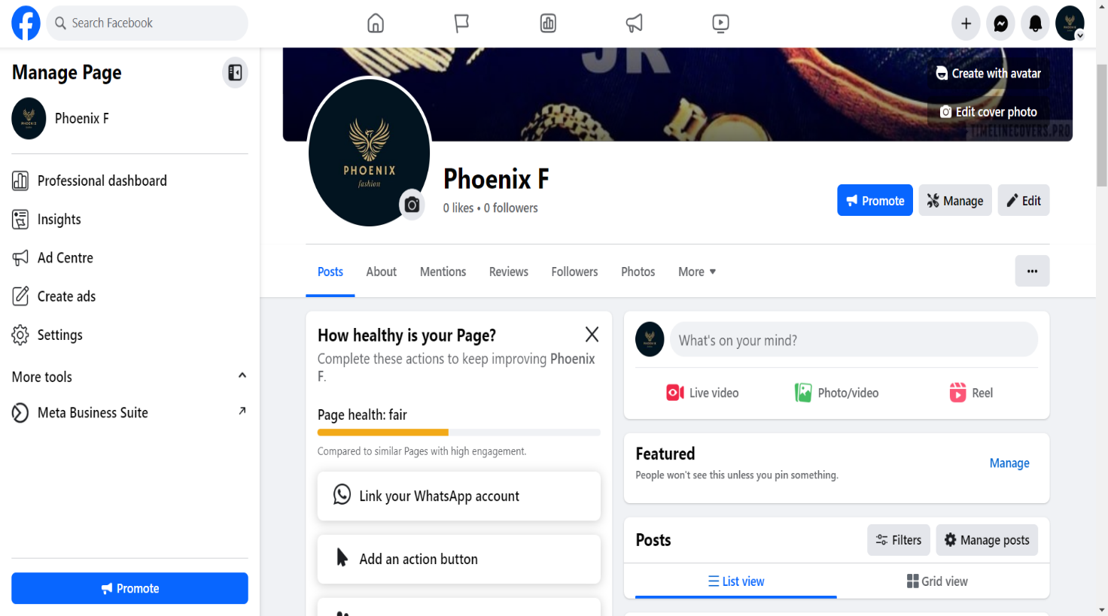

FACEBOOK POSTER

Link: <https://m.facebook.com/story.php?story_fbid=pfbid02j465D2sSqRq6EuGMY37BLHe3CLpND1ou7waKsodmV45pwGd3HTS7YB57maCzYnZ5l&id=61550223766231&mibextid=Nif5oz>

